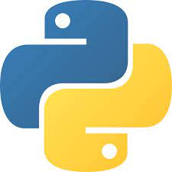

Python Project:

Expense and Money Flow Manager



Done By:

Mohammed Dhruv Khan

Manish Kumar Mandal

Acknowledgement:

I am deeply grateful to my teacher whose mentorship and guidance have been invaluable throughout this endeavour. Their insights and unwavering support have made an incredible impact on making this project. Thank you for providing us the opportunity to learn and grow, by creating this project. Your trust and guidance have been instrumental, and I'm genuinely thankful for your enduring support.

Idea Behind the Project:

The idea behind this project is to create a comprehensive expense and money flow manager that streamlines financial tracking and management. It aims to provide users with a centralized platform to monitor expenses, income, and overall cash flow efficiently. By incorporating intuitive features and user-friendly interfaces, the goal is to empower individuals to make informed financial decisions, effectively manage their resources, and gain a clearer understanding of their financial health.

Code:

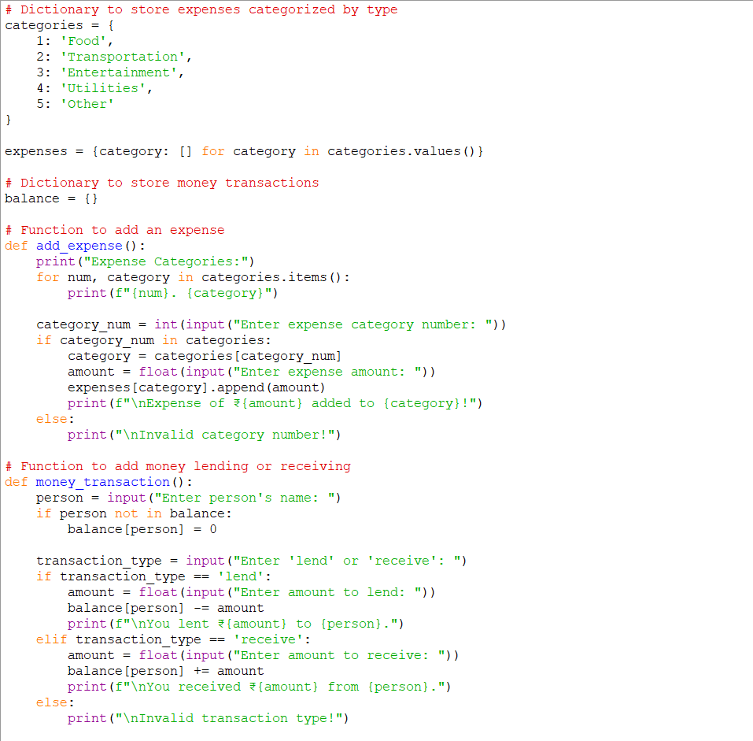

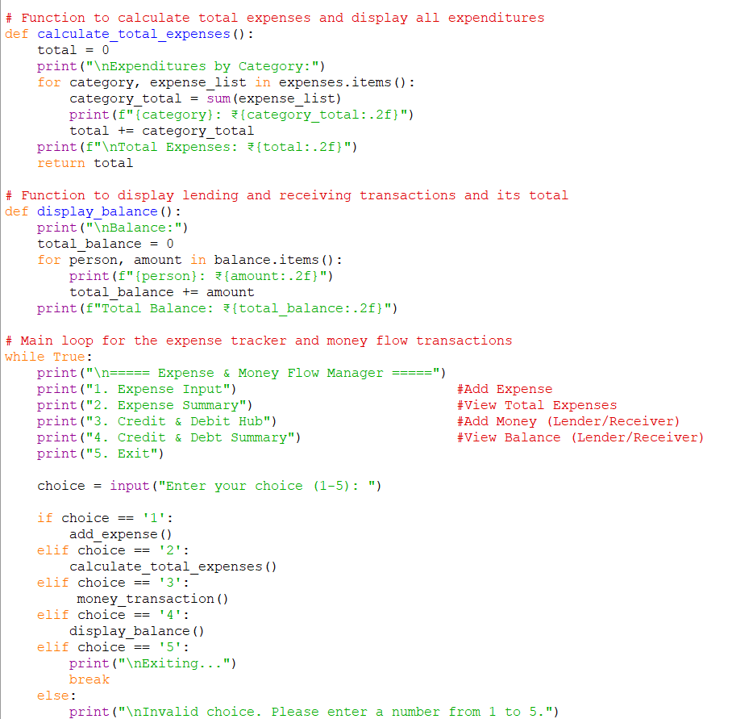

Output:

